# Espot Browser Documentation

## Introduction

Espot Browser is a lightweight yet powerful web browser built using PyQt6. It provides all the essential features of a modern browser, including tab management, cookies, and session management. Moreover, most of its features can be controlled via the Admin Panel.

## Project Structure

The project consists of multiple Python scripts and essential dependency files. Below is a breakdown of the structure and the role of each file:

### 📂 Project Root

* **browser.py** – Contains the main logic for rendering web pages and managing the browser's interface.
* **main.py** – The entry point of the application, initializing and launching the browser.
* **cookies.py** – Handles the storage and management of cookies for user sessions.
* **events.py** – Manages browser events like page navigation, button clicks, and other interactions.
* **globals.py** – Stores global variables and configurations used across multiple modules.
* **login.py** – Handles user authentication and login functionalities.
* **requirements.txt** – Lists all dependencies required to run the project, including PyQt6.
* **Espot Browser.spec** – A specification file for packaging the project into executable (exe) file using PyInstaller.

### 📂 Directories

* **assets/** – Stores static resources such as icons, images, and other UI-related assets.
* **build/** – Contains temporary build files generated during the application packaging process.
* **dist/** – Holds the final packaged version of the application, which can be distributed as an executable.

## 1. Getting Started

### Installation and running in development environment:

1. Create Python virtual environment;

*python -m venv env*

2. Activate the virtual environment:

.\env\Scripts\activate

3. Install dependencies:

pip install -r requirements.txt

4. Run the browser:

python main.py

### Creating the executable file (exe):

1. Activate the virtual env and make sure all requirements are installed (see section 1.1)

2. Run this command to create the exe file:

pyinstaller “Espot Browser.spec”

3. The exe file will be created inside the “dist” directory.

## 2. Configuring the Basics

### Changing the Admin Panel URL:

To change the admin panel URL, change the BASE URL config variable inside the Globals.py file:

1. Open the Global.py file, and go to the line # 9:



2. Change this URL to the new admin panel URL and save the file.

3. Now recreate the exe file (see section 1.2).

### Changing the name of the exe file (browser):

1. Open the “Espot Browser.spec” file.

2. Replace the name variable in both places, line # 38 and line # 62.

3. Now recreate the exe file (see section 1.2).

### Changing the Cloud flare setup

The globals.py contains all the connection details for the CloudFlare.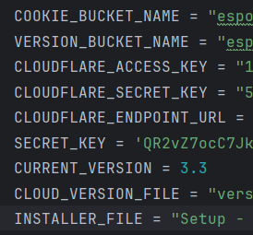

The current version is the version number through which the app identifies itself. This should be the same in the Setup as well.

If the CLOUDFLARE contains some different version, the app will automatically update to that version (when launched through the exe file – after installation).

The CLOUD_VERSION_FILE name should also match the setup file name which is uploaded in the CLOUDFLARE.

## 3. Creating the Setup

### Installing INNO setup compiler

Install the INNO setup compiler from their official website.

<https://jrsoftware.org/isdl.php>

### Open the setup script in the INNO setup compiler

In the project root directory, you will find a file named “Proxy Browser setup.iss”.

Open this file in the INNO setup compiler.

### Configure the variables

Once the file is opened, check that all the variables are correct.

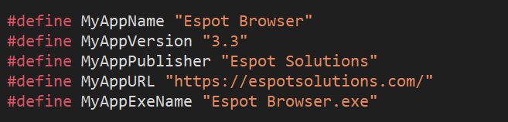

The Version number (MyAppVersion) is very important here as it should match the version of the Exe file (which was written inside the Globals.py file).

The other variables can be configured as wanted.

**Note:**

Also check that the source of the exe file (written inside the .iss script) is correct. This should be the source where the generated exe file is present, otherwise there will be an error.



### Run the Script

Once everything is configured, run the script. The setup will be generated in the Output directory in project root.